POLITICAL PARTIES & ELECTIONS, FALL 2012

THE FUTURE OF WOMEN & CAMPAIGNS, MINORITY CANDIDATES & CAMPAIGNS, AND REDISTRICTING

Semiatin chapters 12 (MacManus), 13 (Stokes-Brown), and 11 (Crouch)
Monday, December 10

12.1 The “Substance Versus Style” section of this chapter (pp. 198-204) reviews the elements of women’s stylistic choices in considerable detail, building on the chapter’s overall premise that style receives far more attention when women run, and crowds out their substantive messages. What factors account for the continuing emphasis on the styles (appearance, dress, hairstyles, eyeglasses versus contacts, use of family, etc. etc.) of women candidates versus male candidates? Will this double standard ever fade away (and if so, what would cause that to happen)?

12.2 What factors account for the higher voter turnout of women versus men? What factors account for the “gender gap” in voting choices (women vote Democrat more than men, and men vote Republican more than women)?

13.1 How do minority candidates (particularly African Americans and Latinos) have to approach campaigns differently than white candidates?

13.2 “While the election of Barack Obama [in 2008] is often cited as a defining moment in which the nation transcended racial and ethnic politics, race and ethnicity undoubtedly remain central cleavages in American politics” (221). Is the electoral landscape different for minority candidates now that Obama has been elected president twice? Is the U.S. destined (doomed?) to have a political system in which race and ethnicity remain central cleavages? Ponder, discuss.

11.1 and 11.2 on the back side!
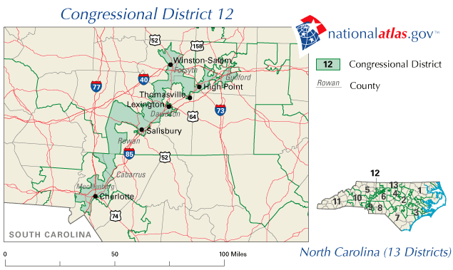

11.1 Above is the North Carolina 12th congressional district that was at issue in Shaw v. Reno (1993) (discussed on p. 180). What’s the problem here? Discuss in light of the principles of redistricting covered in this chapter (especially pp. 182-183).

11.2 Having bipartisan or nonpartisan commissions draw district boundaries (p. 182) seems like such an obviously good idea, compared to the strong partisan interests motivating all other redistricting discussed in the chapter – so why have only 6 states chosen this method?

X. Add your question here….

NEXT on 12/12/12: Electoral and campaign reform; Wayne chapter 10 and Semiatin chapter 14 (Simpson)

